Project Overview – Screen Sense: Screen Time & Digital Well-being Analysis
In today's digital era, screen time has become a major factor influencing mental health, productivity, sleep quality, and overall well-being. With increasing dependence on smartphones, laptops, and digital media, it is essential to understand patterns of screen usage across age groups and demographics. Screen Sense is a data-driven analytical project designed to explore screen-time behaviour, identify trends, and visualize the impact of digital consumption habits.
This project aims to answer key questions such as:
- How much time do users spend on screens daily?
- Which age groups have the highest screen exposure?
- Are there differences in screen usage between genders?
- What portion of time is spent on entertainment vs. educational vs. social media platforms?
- What insights can help promote healthier digital habits?
To derive meaningful insights, the project leverages Power BI as the primary BI and data visualization tool, allowing complex data patterns to be translated into clear, interactive visual stories.

Use of Data Visualization and Power BI
Why Power BI for Screen Usage Analysis
Power BI was chosen due to its powerful data modelling, visual analytics, and interactive dashboarding capabilities. The tool allows integration of raw screen-time data, preprocessing, and creating intuitive charts that help stakeholders understand behavior trends quickly. It supports dynamic filtering, drill-down insights, and real-time data interaction, making it ideal for exploratory behavioural analytics.
This dashboard focuses on simple, surface-level charting to ensure the insights remain easy to understand for all viewers, without advanced KPIs or trend forecasting visuals.
Data Fields Used
The dataset included the following attributes:
- Recreational / Educational Usage (Purpose-based screen time)
- Gender
- Age group
- Health impacts due to screen usage
- Weekday screen time
- Weekend screen time
- Device type used (Mobile, Laptop, Tablet, etc.)
- Total average hours of screen usage
These dimensions provided a structured view of user screen exposure patterns and lifestyle behavior.

Visualizations Used
The dashboard uses basic and easy-to-interpret visual elements, including:
1. Bar & Column Charts
Used to compare:
- Average screen time among different age groups
- Screen usage difference between weekdays vs weekends
- Screen time distribution across device types
These visuals help quickly identify which groups spend the most time on screens and on what devices.

2. Pie / Donut Charts
Used to show the proportion of screen time spent on:
- Recreational use vs Educational use
- Gender-wise participation in screen time
- User-reported health impacts categories (e.g., eye strain, sleep disturbance)
These charts simplify understanding of category distribution and behavioural patterns.

3. Stacked Bar Charts
Used for multi-category comparisons, such as:
- Screen time split between recreational vs educational usage across different age groups
- Device type usage segmented by gender
Stacked visuals help viewers see relational data at a glance.

Dashboard Interaction & Filtering
Basic filters were added such as:
- Age group filter
- Gender filter
- Device type filter
These allow the dashboard to be interacted with, enabling users to explore differences in screen behaviour for specific audience segments.

Purpose of Visual Design
The dashboard was intentionally kept simple and clean, focusing on:
✅ Clear insights without complexity
✅ Easy comparison across demographics
✅ Minimal visual clutter
✅ Straightforward storytelling with basic charts
This ensures that the findings are accessible to a general audience and clearly communicate the impact of screen habits on lifestyle and health.

Conclusion
The Power BI dashboard in the Screen Sense project successfully uses foundational visualization techniques to explore how screen time varies across age, gender, device type, and activity purpose. The focus on basic visual elements—not KPIs or advanced graphs—ensures the report remains user-friendly and highlights essential digital behaviour trends effectively.

Below are the Charts used and their significance also combined with the valuable insights learnt from them :
Average Daily Screen Time by Primary Device and Gender :
This stacked column chart displays the average daily screen time across four primary device types—Smartphone, Laptop, TV, and Tablet—with gender segmentation represented through colour coding (Female in pink, Male in blue). Each column represents approximately 10 hours of total screen time, indicating remarkably consistent device usage patterns across all four device categories.
The visualization reveals a near-perfect gender balance in device usage, with each device type showing roughly equal contributions from both male and female users. The uniform height of all columns (approximately 9-10 hours) suggests that regardless of the primary device choice, total screen time remains consistent across the population. The equal pink-to-blue ratio within each column demonstrates that device preferences are not significantly influenced by gender.
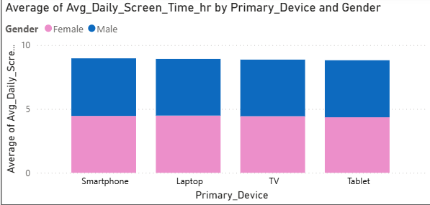
Key Insights:
- Gender-Neutral Device Usage: Both males and females contribute equally to screen time across all device types, indicating that device preferences transcend gender boundaries in modern digital consumption.
- Consistent Total Engagement: All four devices show similar total screen time values, suggesting that individuals maintain comparable usage patterns regardless of their primary device.
- Device Democratization: The equal distribution challenges traditional stereotypes about gender-based technology preferences, highlighting the universal nature of digital device adoption.
Average of Educational and Recreational Use :

This donut chart presents the proportional distribution of screen time between educational and recreational purposes. The visualization uses a simple two-segment design with green representing educational use (42.44%) and orange representing recreational use (57.56%), providing an immediate visual comparison of how screen time is allocated across different usage types.
The data reveals that recreational screen time dominates overall usage, accounting for nearly 58% of total screen hours, while educational purposes represent approximately 42%. This distribution indicates that while a substantial portion of screen time serves educational objectives, entertainment and leisure activities remain the primary drivers of digital device engagement. The difference, though notable, is less dramatic than might be expected, suggesting that screens serve a dual purpose in modern life—functioning as both learning tools and entertainment platforms.
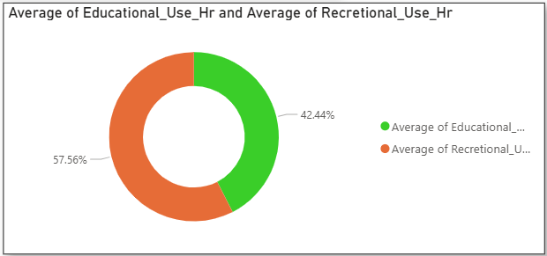
Key Insights:
- Recreation-Led Usage: Recreational activities constitute the majority of screen time, reflecting the strong entertainment function of digital devices in daily routines.
- Significant Educational Component: At over 40%, educational screen time represents a substantial investment in learning activities, indicating the growing role of technology in education and skill development.
- Balanced Digital Life: The relatively modest gap between categories suggests users are successfully integrating productive and leisure activities, rather than using screens exclusively for one purpose.
Average Daily Screen Time by Age :
This line chart tracks the average daily screen time across ages 8 to 18, revealing the developmental trajectory of digital device engagement throughout childhood and adolescence. The blue line demonstrates distinct phases of screen usage intensity, with notable fluctuations that correspond to different developmental and educational stages.
The chart begins at approximately 4.3 hours at age 8, showing initial stability through age 9 before experiencing a dramatic surge between ages 9-12, reaching peak levels of approximately 4.6 hours around age 12. This is followed by a slight dip around ages 13-14 (dropping to about 4.4 hours), before another sharp increase emerges around age 16, climbing back to 4.6 hours and maintaining elevated levels through age 18. The pattern suggests critical transition points that align with educational milestones: the jump to middle school (ages 10-12), early high school adjustment (ages 13-14), and late high school intensification (ages 16-18).
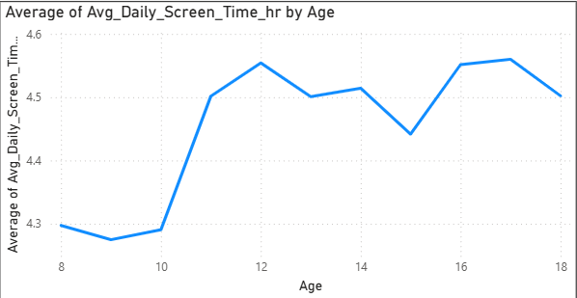
Key Insights:
- Middle School Surge: The most dramatic increase occurs during ages 10-12, likely reflecting increased homework demands, social media adoption, and greater device independence during the transition to middle school.
- Early Teen Plateau: A temporary levelling or slight decrease around ages 13-14 may indicate adjustment periods or parental intervention during early adolescence.
- Late Teen Acceleration: The renewed upward trend in later teenage years corresponds with increased academic workload, college preparation, and greater autonomy in device usage, reaching sustained high levels by age 18.
Average Daily Screen time by Urban/Rural Area and Device Type :
This horizontal stacked bar chart compares device-specific screen time between rural and urban populations, with four device types represented by distinct colours: Laptop (Gray), Smartphone (blue), Tablet (pink), and TV (green). Each bar shows the cumulative screen time contribution from all four device types for the respective geographic category, enabling direct comparison of both total usage and device-specific patterns.
The visualization reveals a substantial urban-rural divide in screen time intensity. Urban populations demonstrate notably higher screen engagement (approximately 5 hours total) compared to rural counterparts (approximately 4 hours).
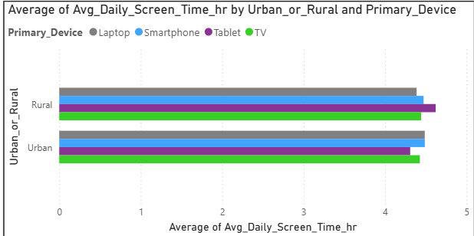
Key Insights:
- Urban Digital Intensity: Urban populations exhibit approximately 25% higher screen time than rural populations, likely driven by better infrastructure, faster internet connectivity, and lifestyle factors that promote increased digital engagement.
- Smartphone Dominance: Smartphones (blue segments) constitute a significant portion of screen time in both settings, reflecting the device's ubiquity and multi-functional nature across all demographics.
- Traditional Media Persistence: TV (green) maintains substantial presence in both urban and rural settings, indicating that traditional media consumption persists alongside newer digital platforms regardless of geographic location.
- Device Diversity: Both populations engage with multiple device types rather than relying on a single platform.
Average Daily Screen Time by Screen Usage Impacts and Age :
This stacked column chart illustrates the average daily screen time across different levels of screen usage impact (Moderate, Low, High Impact, and None) segmented by three age categories: Adults (red), Kids (purple), and Teens (green). Each column represents the cumulative screen time for all age groups within a specific impact category.
The chart reveals that Moderate, Low, and High Impact categories show relatively similar total screen time patterns (approximately 15 hours cumulative), with balanced contributions from all three age groups. However, the "None" category demonstrates notably lower overall screen time (approximately 10-11 hours), suggesting individuals with no reported screen usage impact tend to have reduced screen exposure across all age demographics.
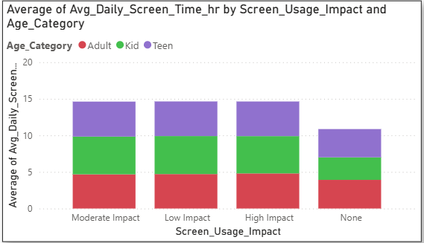
Key Insights:
- Consistent Patterns: Adults, Kids, and Teens maintain proportional representation across most impact levels, indicating screen usage affects all age groups similarly.
- Impact Correlation: Higher reported screen usage impact correlates with increased daily screen time across all age categories.
- Youth Contribution: Teens (green) represent a substantial portion of screen time in all impact categories, highlighting the prevalence of screen usage in younger demographics.
Average Screen time by Urban and Rural Contributors :
This stacked column chart compares average daily screen time between rural and urban populations, with additional breakdown showing the trend indicators (Increase in green, Decrease in red, and Total in blue). The visualization includes a third column representing the overall total across both geographic categories.
The data reveals a striking disparity between rural and urban screen usage patterns. Rural populations demonstrate approximately 4-5 hours of average daily screen time, while urban populations show significantly higher engagement at approximately 9-10 hours per day. The "Total" column, which appears predominantly blue and reaches the highest point, represents the aggregate data and suggests the combined impact of both populations.
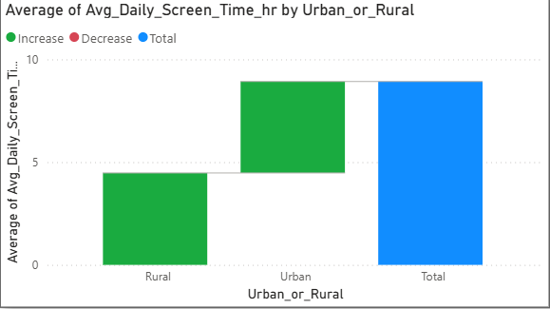
Key Insights:
- Urban-Rural Divide: Urban residents exhibit nearly double the screen time compared to rural counterparts, likely due to greater digital infrastructure, technology access, and lifestyle differences.
- Trend Indicators: The presence of both increase (green) and decrease (red) segments suggests varying individual trajectories within each population group.
- Digital Lifestyle: The substantial difference highlights how geographical location and urbanization significantly influence digital consumption behaviors.

Average Daily Screen Time by Age and Gender :

This horizontal stacked bar chart presents the distribution of average daily screen time across three age categories (Teen, Adult, and Kid) with gender differentiation shown through colour coding—Female (pink) and Male (blue). Each bar represents the total screen time for that age group, with the length of each coloured segment indicating the respective contribution from each gender.
The analysis reveals remarkably balanced gender distribution across all age categories, with teens showing the highest overall screen time (approximately 4 hours combined), followed closely by adults (approximately 3.8 hours), and Kids showing slightly lower engagement (approximately 3.5 hours). The near-equal proportions of pink and blue in each bar indicate that screen usage patterns are relatively consistent between males and females within each age demographic.
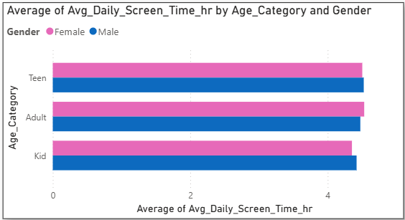
Key Insights:
- Gender Parity: Screen time distribution shows minimal gender disparities across all age groups, suggesting that digital engagement is equally prevalent among males and females.
- Teen Dominance: Teenagers exhibit the highest screen time across both genders, confirming the age group's heightened digital device dependency.
- Consistent Engagement: The similarity in bar lengths across age categories indicates that screen usage is a universal behaviour spanning all developmental stages with only modest variation.
Average Daily Screen Time by Age and Primary Device :
This area chart displays the evolution of average daily screen time across ages 8 to 18, segmented by primary device types: Laptop (blue), Smartphone (pink), Tablet (purple), and TV (orange). The stacked areas represent the cumulative contribution of each device type to total screen time, revealing how device preferences shift throughout childhood and adolescence.
The chart demonstrates a clear upward trajectory in total screen time as age increases, starting from approximately 8-9 hours at age 8 and climbing to nearly 18-20 hours by age 18. The growth pattern shows accelerated increases during the mid-teen years (ages 10-14), followed by continued but slightly moderated growth in later adolescence. Notably, laptop usage (blue area) shows substantial expansion in the teenage years, while smartphone usage (pink) maintains a consistent presence throughout. TV usage (orange) dominates in younger ages but gradually decreases proportionally as children mature.
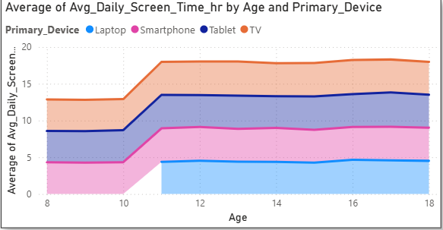
Key Insights:
- Age-Progressive Increase: Screen time more than doubles from age 8 to 18, reflecting increased academic demands, social connectivity needs, and entertainment consumption during developmental years.
- Device Transition: Younger children (8-10) rely heavily on TV and tablets, while teenagers (14+) shift toward laptops and smartphones, indicating evolving technological sophistication and independence.
- Multi-Device Ecosystem: Every Age group shows a consistent pattern.
Average Daily Screen Time by Weekdays/Weekends Analysis :

This column chart compares the average individual screen time between weekends and weekdays, using contrasting colours to highlight behavioural differences—red for weekends and green for weekdays. Unlike cumulative totals, this visualization shows per-person average hours, providing insight into typical daily screen usage patterns across different day types.
The data reveals a notable difference in individual screen time behaviour. Weekend screen time (shown in red) averages approximately 3.3-3.4 hours per person per day, while weekday usage (shown in green) measures approximately 2.6-2.7 hours per person per day. This represents roughly a 25-30% increase in average screen time during weekends compared to weekdays, demonstrating a significant shift in how individuals allocate their time with digital devices when freed from structured weekly obligations.
The difference of approximately 0.7 hours (roughly 40-45 minutes) between weekend and weekday averages indicates that individuals consistently dedicate more time to screens during their days off. This pattern suggests that weekday routines—including work, school, commutes, and other scheduled activities—naturally constrain screen time opportunities, while weekends provide expanded windows for discretionary digital engagement. The moderate but consistent gap reflects a universal behavioral adjustment based on the temporal structure of the week.
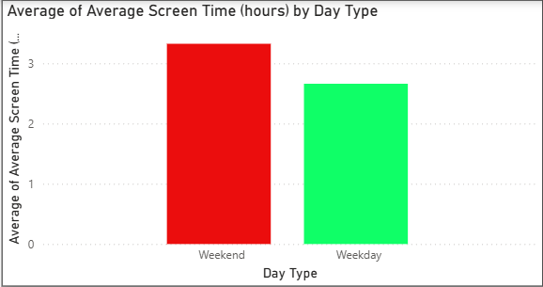
Key Insights:
- Weekend Screen Extension: Individuals spend an average of 40-45 additional minutes on screens during weekend days, representing a 25-30% increase that reflects greater availability of leisure time.
- Weekday Constraint Effect: The lower weekday average (2.6-2.7 hours) suggests that work and educational commitments effectively limit screen time, creating natural boundaries for digital consumption during structured days.
- Consistent Pattern Across Population: The clear distinction between day types indicates a universal behavioural response to weekly schedules, transcending individual differences in demographics or preferences.
- Moderate Usage Levels: Both averages fall within moderate ranges (2-3.5 hours), suggesting that while weekends see increased usage, the population generally maintains reasonable screen time levels rather than exhibiting extreme binge behaviour.
- Leisure Time Allocation: The weekend increase likely represents entertainment, social connection, and recreational content consumption that individuals defer or compress during busier weekdays, indicating screens serve primarily as leisure tools when time permits.

